A tool to help testers to take screenshots quickly

Screenshot Capture tool

Screenshot Capture tool

A tool to help testers to take screenshots quickly

What is it?

ScreenCapture.exe is an in-house developed tool which helps manual testers to take screenshots while executing test cases and save the screenshots with the associated description to a word document.

This will save the testers’ time than having to press PrtSc for a screenshot and switching between windows to paste the screenshot in a word file.

Business Value:

ScreenCapture tool helps save the tester’s time by providing a simple User Interface to take screenshots while they are executing test cases and save those screenshots to a word document with the appropriate description.

This reduces the effort of the tester to repeatedly press the PrtSc key and switch between windows (alt+tab) and manually copy the screenshot to a word document and then write the description of the screenshot.

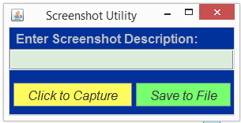

A simple UI presented to the user allows to capture multiple screenshots and associated description of the screenshot, and when the tester is done capturing the screenshots, he/she can save the captured screenshots to a word file by clicking on the “Save to File” button.

Functionality:

ScreenCapture.exe provides a simple yet effective user interface to help testers capture multiple screenshots (along with description) and Save the file to any location of choice in a word format.

Steps to use:

1. Run ScreenCapture.exe

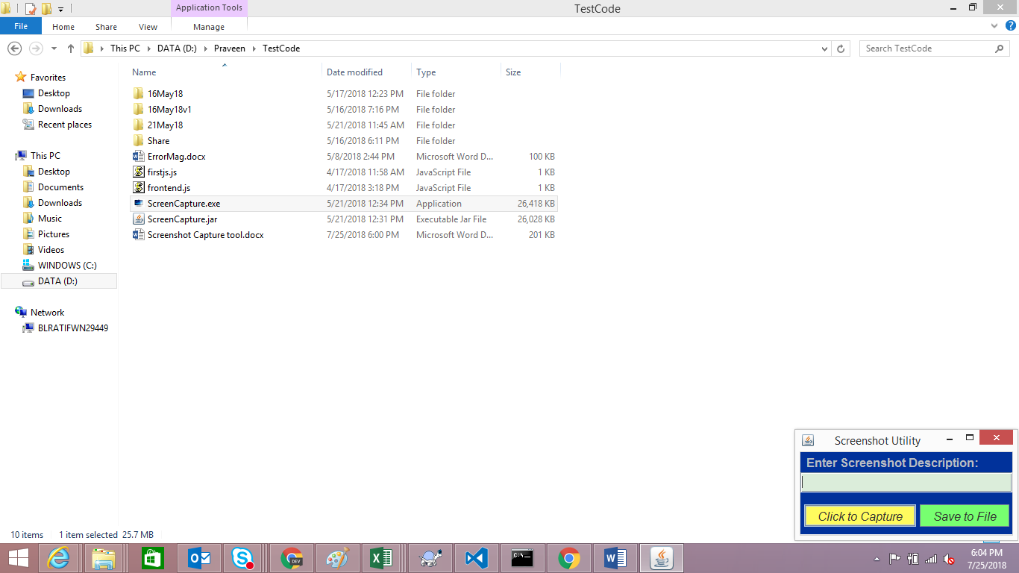

1. Click on “Click to Capture” button, Enter the Description of the screenshot in the text filed provided. As of now there is no limit on the text characters and user can enter as long a description as required.
2. Click “Click to Capture” as many times as it is required to capture screenshots. User may or may not choose to enter the description.
3. Once done taking screenshots, click on “Save to File” button to save the screenshots in a word (.docx) format in a convenient location from the save dialog box.

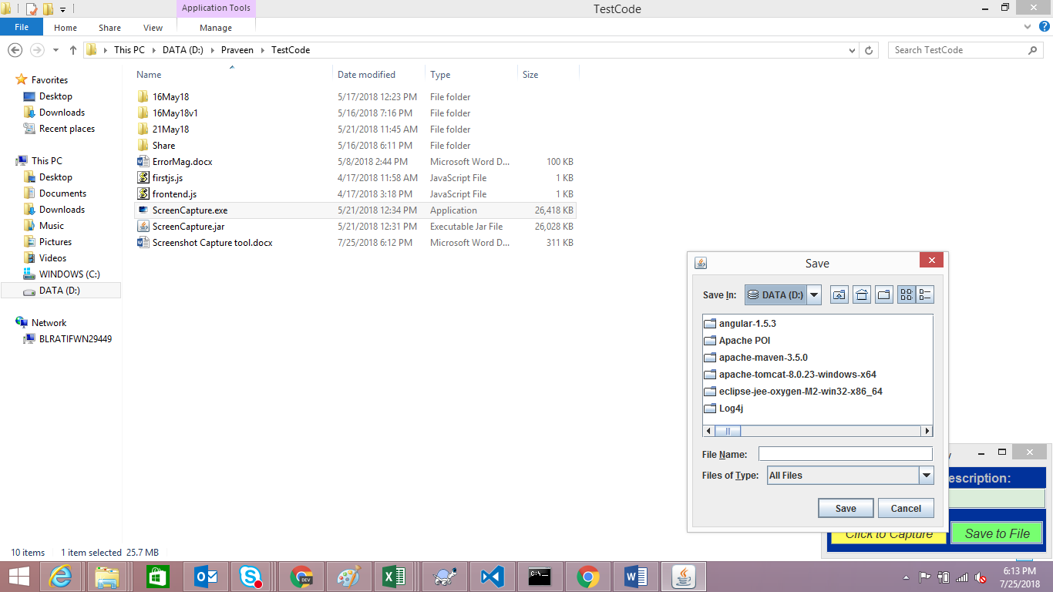

Security:

There are no known security threats to the Operating System or the network on which ScreenCapture.exe is run. ScreenCapture.exe does not need any kind of installation and does not modify the OS registry or variables in any way.

ScreenCapture.exe does not use any third party licensed components, and is built fully on open source technologies. ScreenCapture.exe has been scanned with Symantec Antivirus and no threats have been found.

Technical Description:

**Application Type:** Stand-alone desktop application

**Technical Stack:** Fully Open Source

1. Tool UI: Java Swing, Java AWT
2. Image Capture: Java Robot class
3. MS Word Support: Apache POI

Min. Java/JRE version required: 1.6

**Exe Generated using:** Launch4j

Future Planned Enhancements:

1. Add shortcut keys to capture screenshot and save to file.
2. Ability to open an existing document and append new screenshots to that document.

Know Issues & Workaround:

Issue: After capturing screenshots and saving to a file, if a user clicks on capture screenshot again and saves to a new file, the previous file data also gets added to new file.

Workaround: Close Screencapture.exe after saving screenshots to a file. Run the exe again for capturing a new set of screenshots.